Lincolnshire Runner County Cross Country Championships 2023-24 and League Match 1

Biscathorpe Sunday 7 January 2024

EA Licence CC2023/1067
Biscathorpe, Louth, LN11 9RA

All entries to be made online https://www.race-results.co.uk/results/2024/
Closing date for entries: Friday 5 January (midnight) - sorry, no late entries.

Programme:
10:20 - U11s, 1.9km
10:30 - U15s, U17F, 4.6km
10:55 - U20, Sen/Vet men, 9.5km
11:00 - U13s, 3.5km
11:40 - U20, Sen/Vet women, U17M 5.7km

Entry cost:
U11s £4.50
U13s and U15 (County qualified) - £4.50.
U13s and U15 (non-County qualified and unaffiliated) £6.50
U17s, U20s and Sen/vet (County qualified) - £6.00.
U17s, U20s and Sen/vet (non-County qualified and unaffiliated) - £8.00.

Race numbers and safety pins to be collected on the day. Please keep the race number for league matches if you intend do them (replacement fee of £2). Start times and distances are approximate.

Gold, Silver and Bronze medals will be awarded in all age groups for individuals.
Vet categories are V40, V50 and V60.
Team awards to the first team in each age group (3 to score).
Senior team to consist of combined sen and vet athletes.

Further details and course map http://www.lincsathletics.com/cross countrycountychamps.htm

To be eligible for awards you will need to possess a county qualification by birth or residence. Guest runners (non Lincolnshire and unaffiliated) permitted but not eligible for awards.

Club vests must be worn.

The first 5 finishers (U13, U15, U17, U20) and first 3 seniors in the county champs are eligible to represent Lincolnshire in the inter-county champs (CAUs) should we send teams - and get to wear a county vest.

The results of this county champs will double as match 1 for the Lincolnshire Runner Cross Country League.

Athletes are required to read this statement from UKA
‘An entrant shall be deemed to have made him/herself/their self, familiar with, and agreed to be bound by the UKA Anti-Doping Rules and to submit to the authority of UK Anti-Doping in the application and enforcement of the Anti-Doping Rules. The UKA Anti-Doping Rules apply to entrants participating in the sport of Athletics, for 12 months from the [date of entry], whether or not the licence holder is a citizen of, or resident in, the UK.’

Entering the County Championships will be taken as acceptance of the above statement.

Further information from our cross country sec Gordon Geach: cofsec@lincsathletics.com
Lincolnshire Runner have provided sponsorship for the Cross Country which we are very grateful for.

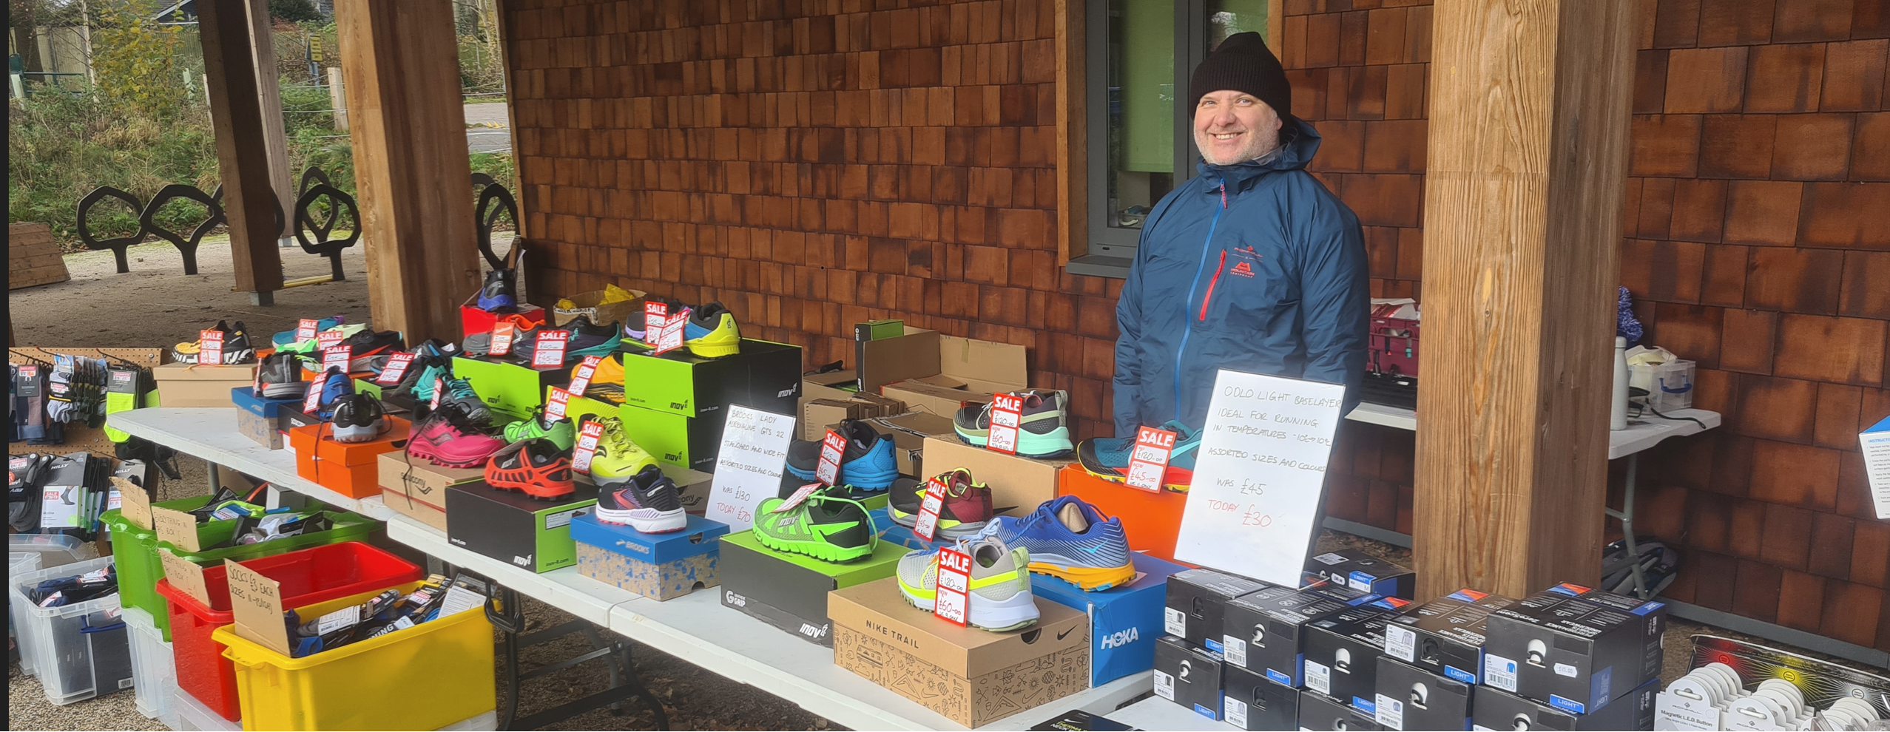

Lincolnshire Runner Will be in attendance at the event, if you would like anything especially please phone Keith (or the shop) on 01522 523326 and he will bring it along.
https://lincolnshirerunner.co.uk/

